The Secret of Thought Power
Original PowerPoint Slides Created by K.V.K. Nehru
The Theosophical Society :: Adyar
2004

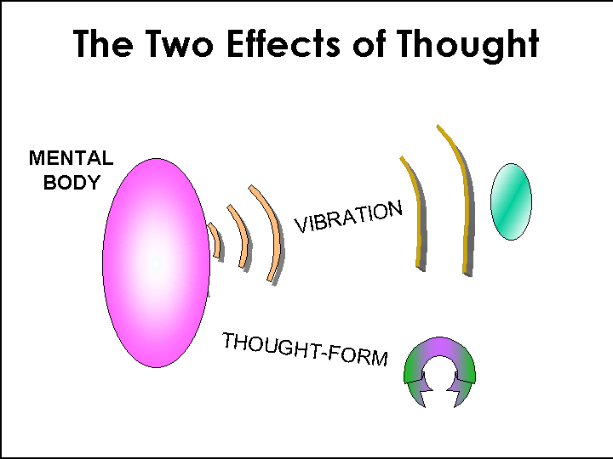

Besant A. and Leadbeater C.W., Thought-Forms, TPH, 1978, pp. 11-17

A thought produces four effects:
(1) Creates Habit--an oft-repeated vibration renders the Mental Body more amenable to that vibration.
(2) A vibration pertaining to the lower Mental levels can, to a certain extent, produce sympathetic vibrations in the Astral Body (lower ‘octave’), as well as the Causal Body (higher ‘octave’). Wholly unselfish and loving thoughts can even draw down the power of the Buddhic levels.
(3) A Vibration generates thoughts of the same type in the recipient’s Mental Body.
(4) A Thought-form clothes in the living matter of the Elemental Essence of the Mental and Astral Planes. Becomes an Elemental. It reproduces in the recipient, not just the same kind of thought, but exactly the same thought.

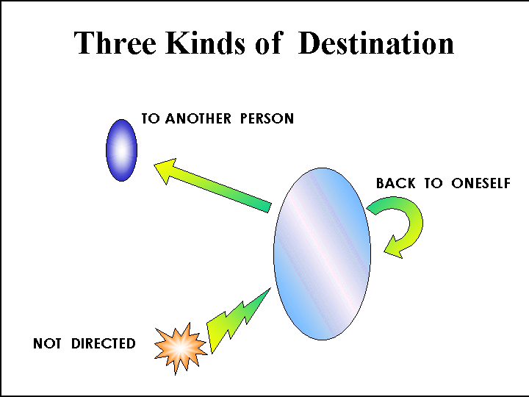

Besant A. and Leadbeater C.W., Thought-Forms, TPH, 1978

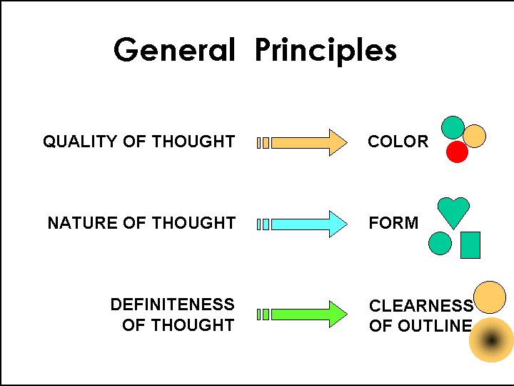

Besant A. and Leadbeater C.W., Thought-Forms, TPH, 1978, pp. 21,24

Quality of thought determines color, nature of thought determines its form and the definiteness of thought the clearness of outline.
Spiritual thoughts even borrow the glory of the Buddhic level—become extremely powerful.
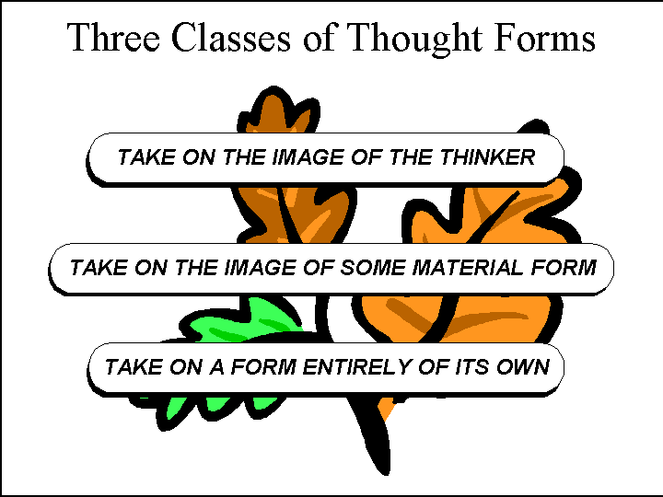

Besant A. and Leadbeater C.W., Thought-Forms, TPH, 1978, pp. 26-30

1. One type takes on the image of the thinker (like when he thinks of himself going to distant places).
2. It may take on the image of some material form (like when thinking of a friend, a theme, novel etc. Explains why “the characters develop a will of their” when someone else can influence the original thought).
3. It may take on a form which is entirely its own. Ex.: Protecting thought forms/shields. “Pure heart and mind are the best protectors against inimical assaults.” The evil thought, finding no entry, returns to the creator.

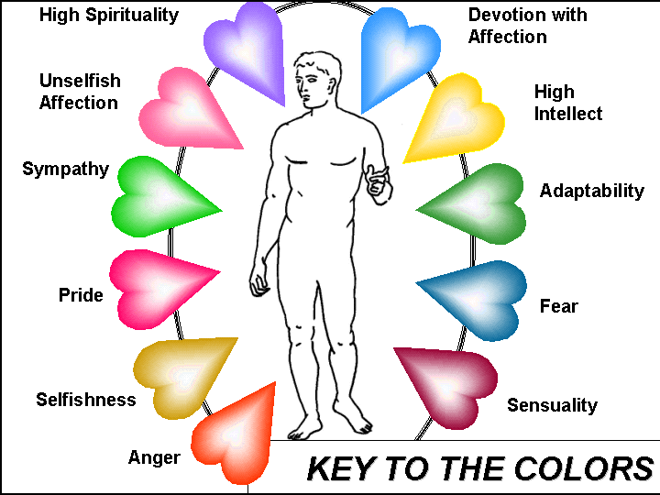

Leadbeater C. W., Man Visible and Invisible, TPH, 1988, inside cover

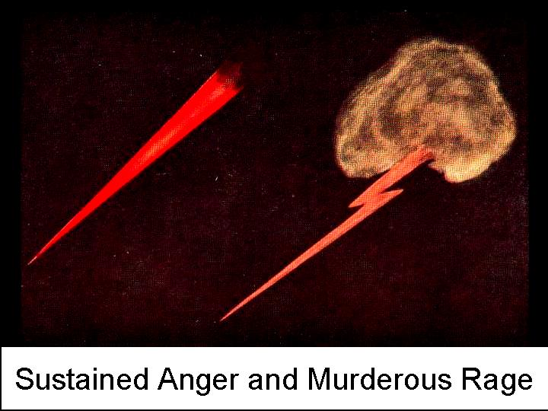
Sustained Anger. The lurid flash from dark clouds was taken from the aura of a rough, intoxicated man as he struck down a woman. The flash darted out at her at the moment before raising his hand. The dirty brown of selfishness even tinges the red of the anger.
In the first one the original thought has been forgotten, and only the sustained and concentrated wrath of red remains.

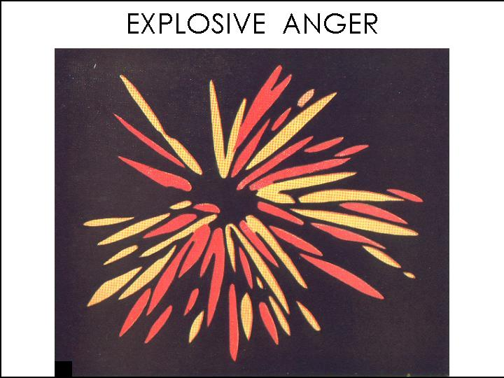

Explosive Anger. In this we see an exhibition of anger of a totally different character. Here is no sustained hatred, but simply a vigorous explosion of irritation. The vacant center shows that the feeling that caused it is already forgotten and no further force is released.



Angry Jealousy. This shows brownish green cloud of jealousy (that is vague), mixed with the red of anger. The interspersed definite flashes of anger are ready to strike at the victim.


Watchful Jealousy. The brownish green color indicates jealousy, and its curious shape shows the eagerness with which the man is watching. The remarkable resemblance with snake with raised head symbolizes his keenness to discover signs which he would detest.

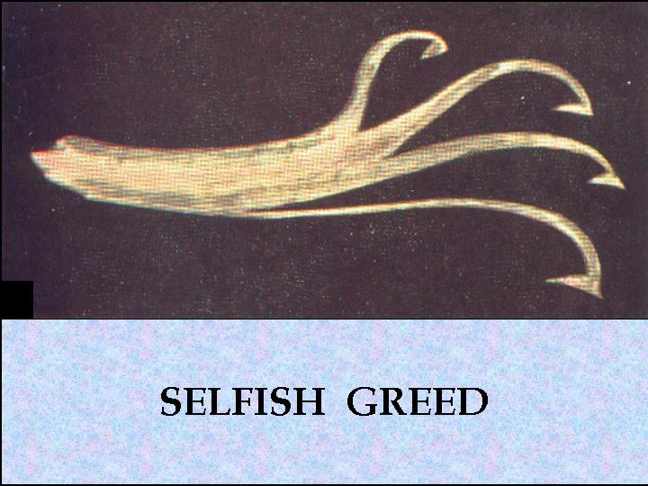

Selfish Greed. From thetinge of muddy green it is evident that the person who is projecting this is ready to employ deceit in order to obtain her desire. The craving is indicated by the reaching hooks. Envy and jealousy are also mixed.



Greed for Drink. This shows a degraded version of selfish greed. The hooked protrusions show craving, while the color and the coarse structure show the low and sensual nature of the appetite. The form remains attached to the Astral body, which is to the left side.

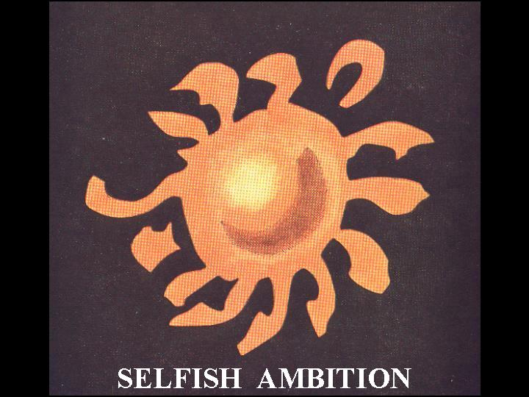

Selfish Ambition. This shows ambition of a lower type: we have here a large stain of the dull brown-gray of selfishness. The form is rising steadily onward toward a definite object with an acquisitiveness to grasp.

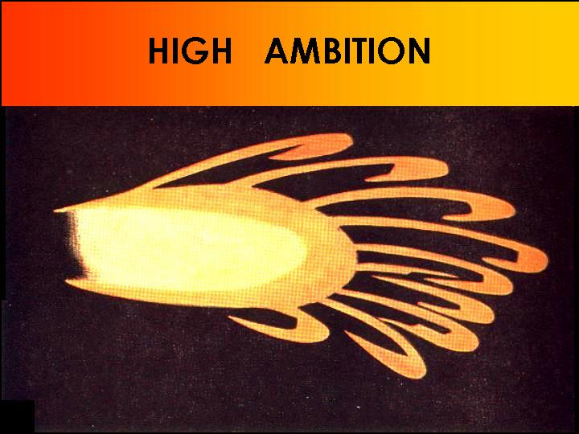

High Ambition. The ambitious quality is shown by the rich deep orange color, and the desire by the hooked extensions which precede the form as it moves. The thought is a good and pure one of its kind since the gray of selfishness is not present.

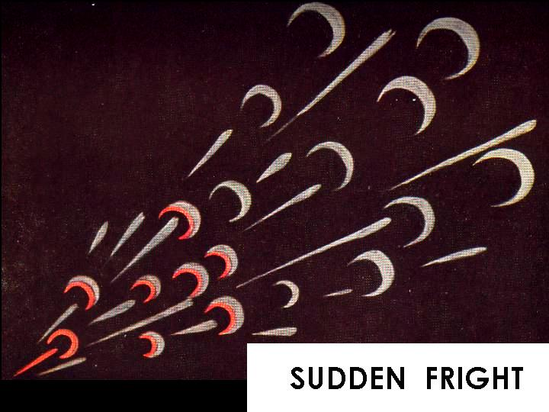
Sudden Fright. Person is not terrified so much as seriously startled. All the crescents to the right side, which must have been expelled earlier, show nothing but the livid gray of fear. A moment later the man has already recovered and beginning to feel angry (scarlet linings) for allowing himself to be startled. The last crescent is totally scarlet indicating that the fright is entirely overcome and only annoyance remains.

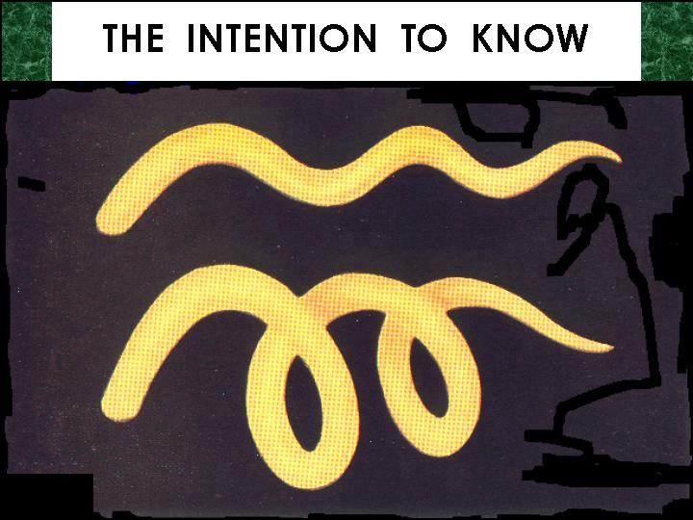
Intention to Know. The earlier stage, shown in the upper form, indicates determination to solve some problem—the intention to know and understand. It was at a meeting that this special shape was encountered. It is strongly tinged with deep orange which indicates conceit (exhibiting the acumen of the questioner). As the answer given was not satisfactory, he inquired further, his thought form deepened in color and changed into the second shape, resembling the cork-screw even more.

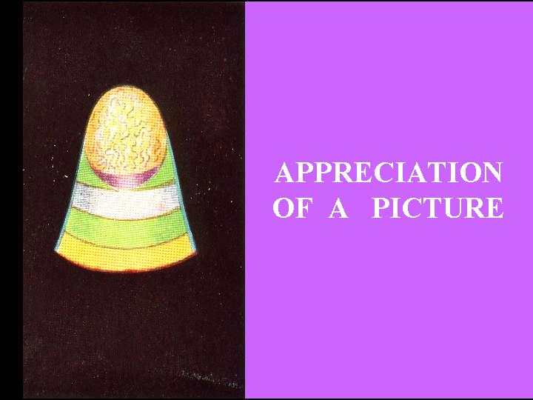
Appreciation of a Picture. The strong pure yellow marks the beholder’s enthusiastic recognition of the technical skill of the artist, while the other colors are the expressions of the emotions evoked. Green sympathy, blue devotion and the violet contemplation to a lofty level. The wavy lines on golden plain indicate the intellectual grasp.

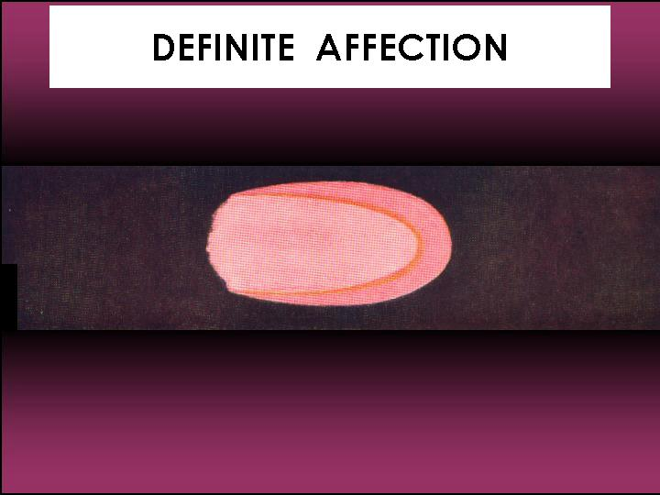

Definite Affection. The slide depicts a thought-form which just left the Astral body of a mother who experienced a gush of affection on seeing her child.
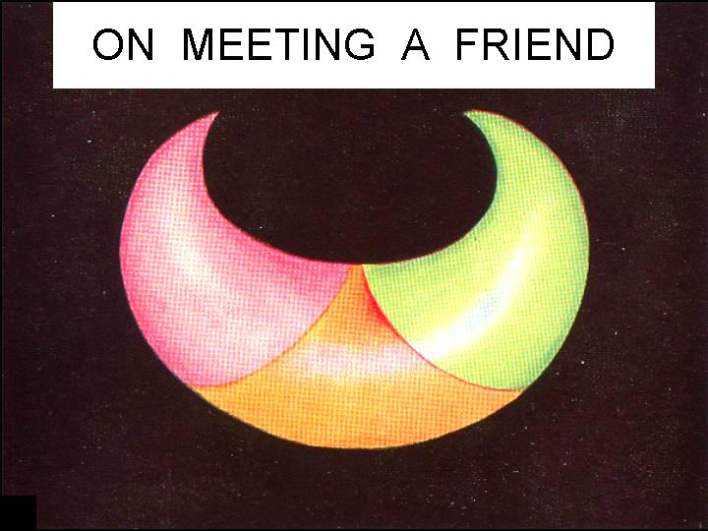
On Meeting a Friend. This shows the feeling of a man on meeting a long-separated friend. The convex surface of the crescent is nearest to the thinker and the two arms stretch out to embrace the friend. The rose betokens the affection felt, the light green depth of sympathy, and clear yellow the sign of the intellectual pleasure with which he anticipates revival of delightful old reminiscences..

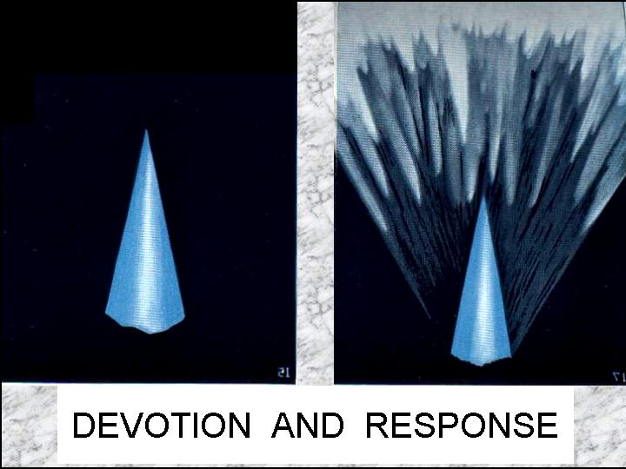
Devotion and Response. The splendid spire of highly developed devotion shows virile vigor, and leaps into being. The sharpness shows clarity, peerless purity of color his utter unselfishness and the upward rush points to courage and conviction.
The response of the Logos to the appeal made to Him is shown. (Answer to the prayer.) An infinite flood of higher forces is always waiting to pour thru’ when a channel is offered.

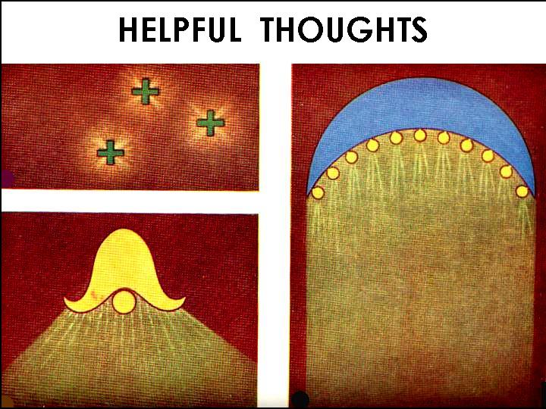
Helpful Thoughts.
These are the recordings of a friend who received helpful thoughts from another. Blue shows devotion, yellow communicating intellectual fortitude and courage, the rosy pink affectionate sympathy.
The right one persisted for a time showering out its luminous yellow ‘message.’ Occasionally they would break into small yellow globules, and sometimes into other shapes (like the crosses).

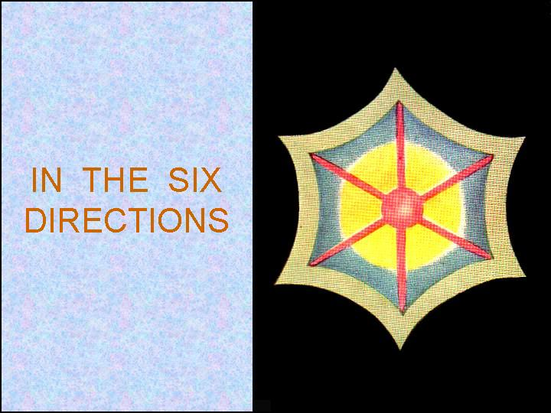

In the six Direcions. A form during meditation. It displays considerable devotion and also the intellectual effort, the blue and yellow showing this. Originally this thought form was circular. But the maker of this was a Hindu; he tried to send his love and sympathy into the six directions (north, east, south, west, zenith and nadir).

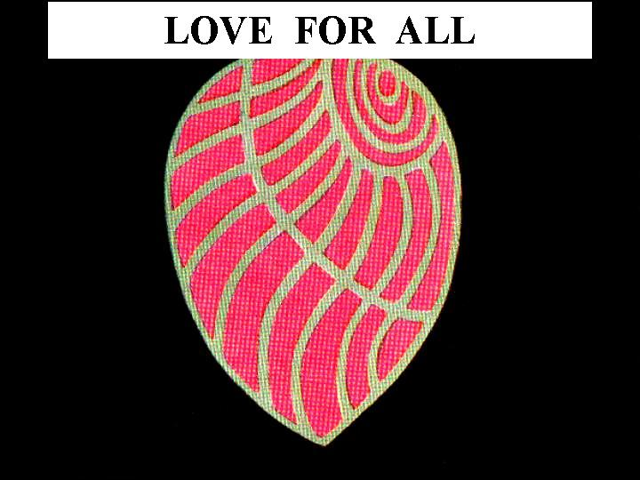

Love for All. Another form found during meditation. The attitude of sympathy and love toward all mankind appears as graceful lines of luminous green and the strong roseate glow of affection shining out between them. The shape is suggestive of a leaf or shell. The precision and clarity show the developed power to think.

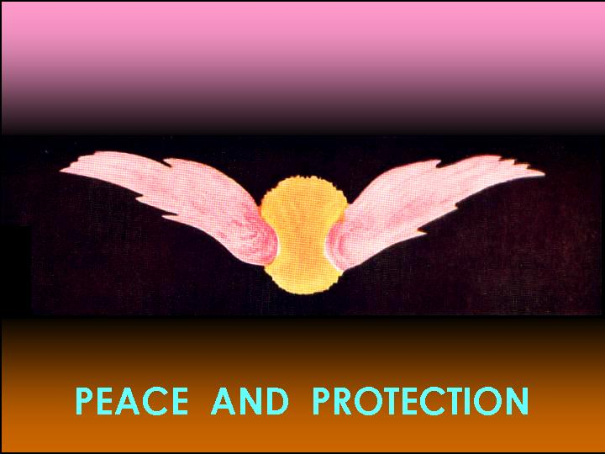

Peace and Protection. This is a thought of love and peace, protection and benediction, sent forth by one who has the power to bless. The affection shows up as the lovely rose-color, and the intellect which guided it shone forth like sunlight at its heart and central support.

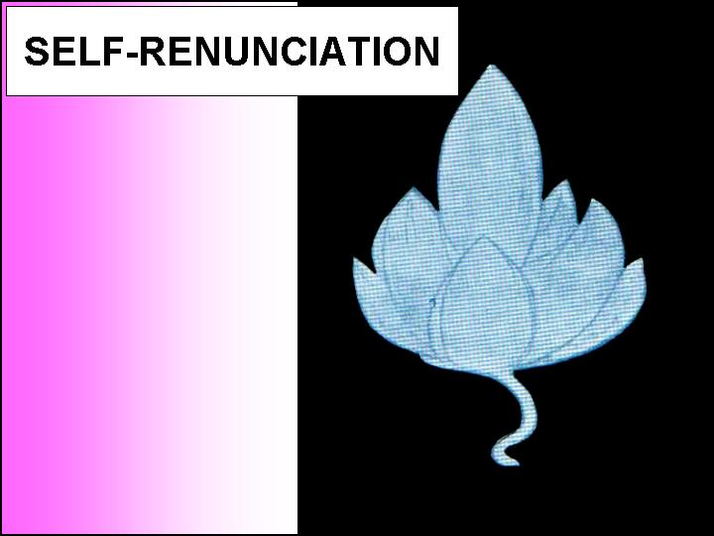

Self-Renunciation. This is an exquisitely beautiful form of devotion, quite new to us. Even though it is suggestive of an open bud, these are not at all copies of any plant or animal forms. It is of the loveliest pale azure, with a glory of white light shining thru’ it which cannot be depicted by any artist.

Works Referred:

Besant A. and Leadbeater C.W., Thought-Forms, TPH, 1978
Leadbeater C.W., Man, Visible and Invisible, TPH, 1988
Leadbeater C.W., The Power and Use of Thought, TPH, 1997

